STATE BANK OF INDIA OFFICERS’ ASSOCIATION
CHANDIGARH CIRCLE
C/O State Bank of India, Local Head Office, Sector 17, Chandigarh
Contact Nos. : 0172-4567134-133-135, Fax:2670812 Email: sbioa.chd@sbi.co.in
www.sbioacha.org

Circular No. 2020/05 Date: 18.01.2020

TO ALL OUR MEMBERS:

Roll out FI & MM Network
Presentation to All General Secretaries & Presidents of all Affiliates of both Federations

We reproduce hereunder the text of AISBOF Circular No 13 dated 17.01.2020 on the captioned subject for the information of members.

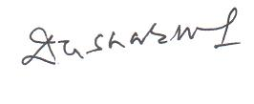
Sincerly Yours,

(Deepak K Sharma)
General Secretary

QUOTE
We reproduce hereunder the joint communiqué dated 17th January, 2020 submitted by the All India State Bank Officers’ Federation and All India State Bank of India Staff Federation to the Deputy Managing Director (HR) & CDO on the captioned subject for your information.

With greetings,
--sd--
(Soumya Datta)
General Secretary

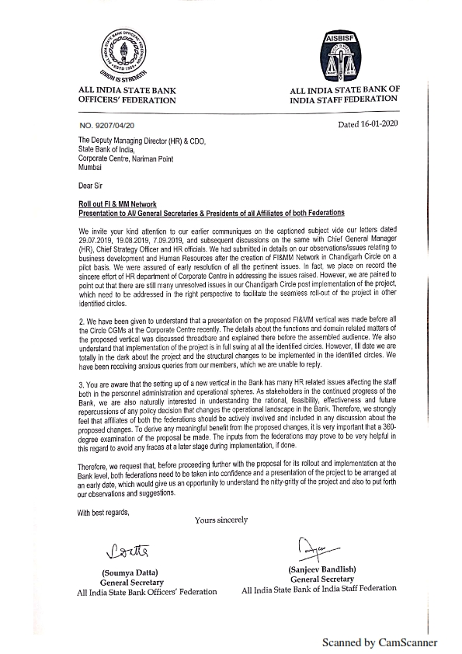

UNQUOTE

